About
Department of MCA

Company Profile

Project Profile

3.1 Project Definition
The Quiz System is a full-stack, web-based application designed to digitize and streamline the process of conducting quizzes through a centralized and automated platform. It enables efficient management of the entire quiz lifecycle, including quiz creation, question management, answer submission, evaluation, and result generation.
The system is built on a role-based architecture, ensuring controlled access and structured operations for different types of users:
- Super Admin – Manages overall platform operations, user access, and system-level insights
- Quiz Master – Responsible for creating, updating, and managing quizzes and questions
- Participant – Engages with the system by attempting quizzes and viewing results and leaderboards
The application is developed using the MERN stack (MongoDB, Express.js, React.js, Node.js), providing a scalable, maintainable, and high-performance solution. The frontend ensures an interactive and responsive user experience, while the backend handles business logic, data processing, and secure communication with the database.
The system focuses on automation and accuracy, where participant responses are captured in real time, evaluated systematically, and converted into meaningful performance metrics. The inclusion of structured data storage (Submissions and Results) enables reliable tracking, analysis, and leaderboard generation.
Additionally, the system incorporates secure authentication and authorization mechanisms, ensuring that only authorized users can access specific functionalities based on their roles. Features such as password encryption, token-based authentication, and controlled routing enhance overall system security.
The primary objective of the Quiz System is to eliminate the limitations of traditional quiz methods by providing a modern, efficient, and user-friendly platform that supports real-time interaction, accurate evaluation, secure data handling, and scalable performance.

3.2 Project Description
The Quiz System is a comprehensive web-based platform designed to manage and conduct quizzes in a structured, automated, and user-friendly manner. The system provides an end-to-end solution that covers all stages of the quiz lifecycle, from creation and management to participation and result evaluation.
The platform is designed with a multi-role architecture, ensuring that each type of user interacts with the system based on their responsibilities and permissions. The Super Admin oversees the system, the Quiz Master manages quiz content, and the Participant interacts with quizzes for assessment purposes.

System Overview
The system allows Quiz Masters to create quizzes with multiple questions, each containing predefined options and correct answers. These quizzes can then be accessed by Participants using a unique quiz code or through available listings.
Participants can attempt quizzes in a structured interface where questions are presented sequentially. Their responses are captured and stored in real time through a dedicated Submission mechanism, ensuring accurate tracking of each answer.
Once the quiz is completed, the system automatically evaluates the responses, calculates the score, and generates a detailed result. The results include performance metrics such as total score, correct answers, wrong answers, and attempts.

Key Functional Flow
- User Authentication
  - Users register and log in securely using email and password
  - Role-based access is enforced after login
- Quiz Creation (Quiz Master)
  - Create quiz with title, description, and settings
  - Add multiple questions with options and correct answers
- Quiz Participation (Participant)
  - Join quiz using a quiz code
  - Attempt quiz through an interactive interface
  - Submit answers
- Answer Processing
  - Each response is stored in the Submission entity
  - System evaluates correctness and assigns marks
- Result Generation
  - Final score is calculated based on submissions
  - Result is stored and displayed
- Leaderboard Display
  - Rankings are generated using aggregated submission data
  - Participants can compare their performance

System Features
- Automated quiz evaluation and result generation
- Real-time answer submission and tracking
- Role-based dashboards and access control
- Leaderboard generation for performance comparison
- Secure authentication and data handling
- Responsive and user-friendly interface

Technical Approach
The system follows a client-server architecture, where:
- The frontend (React.js) handles UI rendering and user interactions
- The backend (Node.js & Express.js) processes requests and manages logic
- The database (MongoDB) stores structured data such as users, quizzes, submissions, and results
Communication between frontend and backend is done through REST APIs, ensuring modular and scalable development.

3.3 Existing System / Work Environment
The current methods used for conducting quizzes are primarily based on manual processes or basic digital tools, which are not suitable for modern requirements. These systems lack automation, scalability, and structured management, resulting in inefficiencies for both administrators and participants.
In many environments, quizzes are conducted using paper-based formats, spreadsheets, or simple online forms. While these approaches serve basic purposes, they fail to provide a complete and efficient solution for managing quiz workflows.

Current Work Environment

1. Paper-Based Systems
- Quizzes are conducted manually using printed question papers
- Participants write answers on paper
- Evaluation is performed manually by instructors

2. Basic Digital Tools
- Use of tools like Google Forms or spreadsheets
- Limited functionality for quiz management
- No structured backend or system architecture

Limitations of the Existing System

1. Manual Evaluation Process
Answer checking and score calculation are done manually, which is time-consuming and prone to human errors.

2. No Real-Time Results
Participants do not receive instant feedback after completing quizzes, reducing engagement and efficiency.

3. Inefficient Data Management
Data is stored in unstructured formats such as spreadsheets, making it difficult to manage, retrieve, and analyze.

4. Lack of Role-Based Access
There is no proper distinction between administrators and participants, leading to poor control over system operations.

5. Limited Accessibility
Traditional systems are restricted to specific locations and cannot be accessed easily from different devices or remotely.

6. Poor User Experience
Basic systems lack interactive interfaces, smooth navigation, and modern UI elements, resulting in low user engagement.

7. Security Limitations
There is no proper implementation of authentication or authorization, making data vulnerable and access uncontrolled.

3.4 Problem Statements
The existing quiz systems, whether manual or based on basic digital tools, face several limitations that affect efficiency, accuracy, and user experience. These challenges highlight the need for a more structured and automated solution.

Identified Problems

1. Lack of Automation
Current systems rely heavily on manual processes for quiz creation, evaluation, and result generation, leading to inefficiencies and delays.

2. Time-Consuming Evaluation
Manual checking of answers and calculation of scores require significant time and effort, especially when handling large numbers of participants.

3. Absence of Real-Time Feedback
Participants do not receive immediate results or performance insights, reducing engagement and limiting the effectiveness of the assessment process.

4. Poor Data Organization
Quiz data, responses, and results are often stored in unstructured formats, making it difficult to manage, retrieve, and analyze information efficiently.

5. No Role-Based System
There is no clear separation of responsibilities between administrators and participants, resulting in lack of control and inefficient system management.

6. Limited Accessibility
Existing systems are not easily accessible across devices or locations, restricting users from participating in quizzes remotely.

7. Weak Security Mechanisms
Lack of proper authentication and authorization leads to insecure data handling and unauthorized access.

8. Lack of Performance Tracking
There is no structured way to track participant performance, generate insights, or compare results through leaderboards.

3.5 Need for New System
The limitations identified in the existing quiz systems clearly indicate the need for a modern, automated, and structured solution. Traditional methods are no longer sufficient to meet the growing demands for efficiency, scalability, and user experience.
A new system is required to overcome the challenges of manual processing, delayed results, poor data management, and lack of security.

Key Needs

1. Automation of Quiz Processes
There is a need to automate quiz creation, answer evaluation, and result generation to reduce manual effort and improve efficiency.

2. Real-Time Evaluation and Feedback
The system should provide instant result calculation and feedback to participants, enhancing engagement and learning outcomes.

3. Centralized Data Management
A structured system is required to store and manage data such as users, quizzes, submissions, and results in an organized and accessible manner.

4. Role-Based Access Control
The system must support multiple user roles (Super Admin, Quiz Master, Participant) with clearly defined permissions and functionalities.

5. Improved Accessibility
The application should be accessible from multiple devices and locations, allowing users to participate in quizzes anytime and anywhere.

6. Enhanced Security
Secure authentication and authorization mechanisms are necessary to protect user data and prevent unauthorized access.

7. Performance Tracking and Analytics
The system should provide features such as result analysis and leaderboards to track participant performance effectively.

8. Better User Experience
A modern and responsive interface is required to provide smooth navigation, interactive elements, and an engaging experience for all users.

3.6 Proposed System & Features
To overcome the limitations of the existing system, a modern web-based Quiz System is proposed. The system is designed to provide an automated, scalable, and secure platform for managing quizzes with a seamless user experience.
The proposed system introduces a role-based architecture, structured data handling, and real-time processing to ensure efficiency and accuracy across all operations.

Proposed System Overview
The system allows:
- Quiz Masters to create and manage quizzes and questions
- Participants to join quizzes, submit answers, and view results
- Super Admins to oversee system activities and manage users
All interactions are handled through a centralized platform, ensuring consistency, control, and accessibility.

Core Features

1. User Authentication & Authorization
- Secure login and registration system
- Password encryption using hashing techniques
- Token-based authentication (JWT)
- Role-based access control

2. Role-Based System

Super Admin
- View platform data (users, quizzes, reports)
- Manage users and system-level operations

Quiz Master
- Create, update, and delete quizzes
- Add and manage questions
- View quiz results and participant performance

Participant
- Join quizzes using quiz code
- Attempt quizzes through interactive UI
- View results and leaderboard

3. Quiz Management
- Create quizzes with title, description, and settings
- Assign multiple questions to each quiz
- Manage quiz lifecycle (create, update, delete)

4. Question Management
- Add multiple-choice questions
- Define options and correct answers
- Store questions linked to specific quizzes

5. Quiz Attempt System
- Participants can join quizzes using a unique code
- Questions are displayed in a structured interface
- Answers are submitted in real time

6. Submission Handling
- Each answer is stored in the Submission entity
- Tracks selected answer, correctness, and marks awarded
- Enables accurate evaluation and tracking

7. Automated Evaluation
- System automatically checks answers
- Calculates score based on correct responses
- Eliminates manual errors

8. Result Generation
- Generates detailed results after quiz completion
- Displays score, correct answers, wrong answers, and attempts
- Stores results for future reference

9. Leaderboard System
- Ranks participants based on performance
- Uses aggregated submission data
- Enables performance comparison

10. Secure System Design
- Protected routes and APIs
- Role-based access restrictions
- Secure data handling and storage

11. Responsive User Interface
- Clean and modern UI design
- Smooth navigation and interaction
- Works across different devices

Advantages of Proposed System
- Eliminates manual evaluation and errors
- Provides real-time results and feedback
- Ensures secure and structured data management
- Supports multiple users and roles efficiently
- Enhances user engagement through interactive UI

3.7 Scope
The scope of the Quiz System defines the boundaries and extent of functionalities provided by the application. The system is designed to support quiz management and participation in a controlled and efficient manner.

In Scope
The system covers the following functionalities:

1. User Management
- User registration and login
- Role-based access (Super Admin, Quiz Master, Participant)

2. Quiz Management
- Creation, updating, and deletion of quizzes
- Management of quiz details and structure

3. Question Management
- Adding and managing multiple-choice questions
- Defining options and correct answers

4. Quiz Participation
- Joining quizzes using a unique quiz code
- Attempting quizzes through an interactive interface

5. Submission & Evaluation
- Recording participant responses in real time
- Automatic evaluation of answers
- Score calculation

6. Result & Leaderboard
- Displaying quiz results
- Generating leaderboard based on performance

7. Security & Access Control
- Authentication using secure methods
- Role-based authorization

Out of Scope
The following functionalities are not included in the current system:
- Real-time multiplayer quiz synchronization
- Advanced analytics and reporting dashboards
- AI-based question generation
- Integration with third-party platforms
- Mobile application (native apps) .

3.8 Outcomes
The implementation of the Quiz System results in a structured, automated, and efficient platform for managing and conducting quizzes. The system delivers measurable improvements in performance, accuracy, and user experience compared to traditional methods.

Key Outcomes

1. Automated Quiz Management
The system enables complete automation of quiz creation, question management, evaluation, and result generation, reducing manual effort and operational complexity.

2. Accurate and Reliable Evaluation
Participant responses are evaluated automatically using predefined logic, ensuring accuracy and eliminating human errors in score calculation.

3. Real-Time Results and Feedback
Participants receive instant results after completing quizzes, improving engagement and providing immediate performance insights.

4. Structured Data Management
All data, including users, quizzes, submissions, and results, is stored in a well-organized database, enabling efficient retrieval and analysis.

5. Role-Based System Efficiency
The system clearly separates functionalities for Super Admin, Quiz Master, and Participant, improving control, usability, and system organization.

6. Enhanced User Experience
The application provides a modern, responsive, and intuitive interface, ensuring smooth navigation and better user interaction.

7. Performance Tracking and Leaderboards
The system enables tracking of participant performance and ranking through leaderboards, promoting competitiveness and engagement.

8. Improved Security
Secure authentication and authorization mechanisms ensure safe access to the system and protect user data.

Overall Outcome
The Quiz System transforms traditional quiz processes into a fully digital, scalable, and efficient solution, improving accuracy, reducing time consumption, and enhancing the overall experience for both administrators and participants.

3.9 Tools & Technology Used
The Quiz System is developed using modern web technologies and tools that ensure scalability, performance, and efficient development. The system follows the MERN stack architecture, combining frontend, backend, and database technologies.

1. Frontend Technologies

React.js
- Used for building the user interface
- Enables component-based architecture
- Provides dynamic and responsive UI

HTML5
- Structures the web pages

CSS3
- Used for styling and layout design
- Ensures responsive and modern UI

JavaScript (ES6+)
- Handles client-side logic and interactivity

2. Backend Technologies

Node.js
- Provides runtime environment for server-side development
- Enables scalable and high-performance applications

Express.js
- Framework for building REST APIs
- Handles routing and middleware efficiently

3. Database

MongoDB
- NoSQL database used for storing application data
- Supports flexible schema design
- Handles collections such as Users, Quizzes, Questions, Submissions, and Results

4. Development Tools

Visual Studio Code
- Code editor used for development
- Supports extensions for better productivity

Postman
- Used for testing API endpoints
- Helps in debugging and validating backend APIs

5. Libraries & Packages

Axios
- Used for API communication between frontend and backend

React Router
- Handles client-side routing and navigation

JWT (JSON Web Token)
- Used for secure authentication and session management

Bcrypt.js
- Used for password hashing and encryption

React Hot Toast
- Provides user notifications and alerts

6. Version Control

Git & GitHub
- Used for source code management
- Enables version tracking and collaboration

3.10 Project Plan
The development of the Quiz System follows a structured approach to ensure systematic progress, efficient resource utilization, and timely completion. The project is divided into multiple phases, each focusing on specific tasks and deliverables.

1. Planning Phase
- Identification of project requirements
- Understanding system objectives and user needs
- Defining project scope and features

2. Analysis Phase
- Studying existing systems and identifying limitations
- Defining problem statements
- Preparing system requirements and flow

3. Design Phase
- Designing system architecture (Frontend, Backend, Database)
- Creating UI layouts and user flows
- Designing database schema (User, Quiz, Question, Submission, Result)

4. Development Phase

Frontend Development
- Building UI using React.js
- Implementing authentication pages
- Creating dashboards and quiz interfaces

Backend Development
- Creating REST APIs using Node.js and Express.js
- Implementing authentication and authorization
- Developing quiz, question, submission, and result logic

5. Integration Phase
- Connecting frontend with backend APIs
- Ensuring smooth data flow between client and server
- Handling API responses and UI updates

6. Testing Phase
- Testing individual modules (unit testing)
- Testing complete system flow (integration testing)
- Fixing bugs and improving performance

7. Deployment Phase
- Running the application in a production-like environment
- Ensuring system stability and performance
- Final validation of all features

8. Maintenance Phase
- Fixing issues after deployment
- Improving system performance
- Adding new features and enhancements

Requirement Analysis

4.1 Feasibility Study
The feasibility study evaluates whether the Quiz System can be successfully developed and implemented within the given constraints. It analyzes the system from different perspectives to ensure viability.

1. Technical Feasibility
The system is technically feasible as it is built using widely adopted technologies such as:
- React.js for frontend development
- Node.js and Express.js for backend
- MongoDB for database
These technologies are reliable, scalable, and well-supported, making development and maintenance efficient.

2. Operational Feasibility
The system is user-friendly and easy to operate for all types of users:
- Quiz Masters can manage quizzes without technical expertise
- Participants can easily join and attempt quizzes
- The interface is intuitive and responsive
This ensures smooth adoption in real-world scenarios.

3. Economic Feasibility
The system is cost-effective as:
- It uses open-source technologies
- No expensive licensing or infrastructure is required
- Development and maintenance costs are minimal

4. Schedule Feasibility
The project can be completed within a defined timeline by following a structured development approach (planning, design, development, testing, deployment).

4.2 Users of the System
The Quiz System is designed to support multiple types of users, each with specific roles and responsibilities. The system follows a role-based access model, ensuring that users can only access functionalities relevant to their role.

1. Super Admin

Description:
The Super Admin is the highest-level user in the system, responsible for managing overall platform operations.

Responsibilities:
- Manage users (Quiz Masters and Participants)
- View system-level data and reports
- Monitor platform activity
- Ensure smooth functioning of the system

2. Quiz Master

Description:
The Quiz Master is responsible for creating and managing quizzes and related content.

Responsibilities:
- Create, update, and delete quizzes
- Add and manage questions
- Define correct answers and marks
- View participant results and performance

3. Participant

Description:
The Participant is the end user who interacts with the system to attempt quizzes.

Responsibilities:
- Register and log in to the system
- Join quizzes using quiz codes
- Attempt quizzes
- Submit answers
- View results and leaderboard

Role-Based Access Summary
Role | Access Level | Key Actions
Super Admin | Full Access | Manage users, monitor system
Quiz Master | Content Management | Create quizzes, manage questions
Participant | Limited Access | Attempt quizzes, view results

4.3 Modules
The Quiz System is divided into multiple functional modules, each responsible for a specific set of operations. This modular approach ensures better organization, maintainability, and scalability of the system.

1. Authentication Module

Description:
Handles user registration, login, and secure access to the system.

Features:
- User registration (Participant / Quiz Master)
- User login and logout
- Forgot password and reset password functionality
- JWT-based authentication
- Password encryption using Bcrypt

2. User Management Module (Super Admin)

Description:
Allows the Super Admin to manage users and monitor system activity.

Features:
- View all users (Quiz Masters and Participants)
- Manage user roles and access
- Monitor platform-level data

3. Quiz Management Module (Quiz Master)

Description:
Enables Quiz Masters to create and manage quizzes.

Features:
- Create new quizzes
- Update quiz details
- Delete quizzes
- View list of quizzes

4. Question Management Module

Description:
Handles creation and management of quiz questions.

Features:
- Add multiple-choice questions
- Define options (A, B, C, D)
- Set correct answers
- Edit and delete questions

5. Quiz Participation Module (Participant)

Description:
Allows participants to join and attempt quizzes.

Features:
- Join quiz using quiz code
- Display questions in structured format
- Navigate through questions
- Submit answers

6. Submission Module

Description:
Stores and processes participant responses for each question.

Features:
- Records selected answers
- Tracks correctness of responses
- Stores marks awarded
- Maintains submission history

7. Result Management Module

Description:
Generates and manages quiz results.

Features:
- Automatic score calculation
- Display total score, correct and wrong answers
- Store results for future reference

8. Leaderboard Module

Description:
Displays ranking of participants based on performance.

Features:
- Rank participants based on score
- Show performance comparison
- Use aggregated submission data

4.4 Process Model
The development of the Quiz System follows an Iterative and Incremental Process Model, where the system is built and improved in multiple stages. This approach allows continuous refinement, testing, and enhancement of features throughout the development lifecycle.

Process Model Overview
In this model, the system is developed in small functional modules (iterations). Each iteration includes:
- Requirement understanding
- Design
- Development
- Testing
- Feedback and improvement
This cycle is repeated until the complete system is developed.

Development Phases

1. Requirement Identification
- Understanding system needs and objectives
- Identifying user roles and functionalities
- Defining system scope

2. System Design
- Designing frontend layouts and user flows
- Planning backend architecture and database schema
- Structuring modules (Authentication, Quiz, Submission, Result)

3. Implementation (Development)
- Developing frontend using React.js
- Creating backend APIs using Node.js and Express.js
- Implementing database models in MongoDB

4. Testing
- Testing individual modules
- Verifying API responses
- Checking complete system flow
- Fixing bugs and errors

5. Deployment
- Running the system in a working environment
- Validating features and performance

6. Iteration & Improvement
- Making changes based on testing and feedback
- Improving UI, logic, and performance
- Adding enhancements (leaderboard, security, validations)

Why Iterative Model is Suitable
- Allows gradual development of features
- Helps in early detection of issues
- Supports continuous improvement
- Flexible to changes during development
- Ensures better quality and stability

4.5 Hardware & Software Requirements
This section defines the essential hardware and software requirements needed for the development, deployment, and execution of the Quiz System. These requirements ensure that the system operates efficiently and supports all functionalities without performance issues.

1. Hardware Requirements
The system can run on standard computing devices with the following specifications:
- Processor: Intel i3 or higher (or equivalent)
- RAM: Minimum 4 GB (8 GB recommended for development)
- Storage: 256 GB SSD or higher
- System Type: 64-bit Operating System
- Input Devices: Keyboard and Mouse
- Output Devices: Monitor or Display Screen
These specifications are sufficient to support development tools, server processes, and browser-based execution.

2. Software Requirements

Operating System
- Windows / macOS / Linux

Frontend Technologies
- React.js
- HTML5
- CSS3
- JavaScript (ES6+)

Backend Technologies
- Node.js
- Express.js

Database
- MongoDB

Development Tools
- Visual Studio Code

API Testing Tool
- Postman

Web Browser
- Google Chrome / Microsoft Edge

3. Supporting Libraries & Tools
- Axios – API communication
- React Router – Navigation handling
- JWT (JSON Web Token) – Authentication
- Bcrypt.js – Password encryption
- React Hot Toast – Notifications

4.6 Use Cases
Use cases describe how different users interact with the system to perform specific actions. The Quiz System supports multiple use cases based on user roles, ensuring clear functionality and interaction flow.

1. Use Case: User Registration
- Actor: Participant / Quiz Master
- Description: User registers by providing basic details
- Precondition: User is not already registered
- Postcondition: User account is created

2. Use Case: User Login
- Actor: All Users
- Description: User logs into the system using email and password
- Precondition: User must be registered
- Postcondition: User is authenticated and redirected to dashboard

3. Use Case: Create Quiz
- Actor: Quiz Master
- Description: Quiz Master creates a new quiz
- Precondition: User must be logged in as Quiz Master
- Postcondition: Quiz is created and stored

4. Use Case: Add Questions
- Actor: Quiz Master
- Description: Add questions to a quiz with options and correct answers
- Precondition: Quiz must exist
- Postcondition: Questions are stored in database

5. Use Case: Manage Quiz
- Actor: Quiz Master
- Description: Update or delete quiz details
- Precondition: Quiz must exist
- Postcondition: Quiz is updated or removed

6. Use Case: Join Quiz
- Actor: Participant
- Description: Participant joins a quiz using a quiz code
- Precondition: Quiz must exist
- Postcondition: Participant enters quiz interface

7. Use Case: Attempt Quiz
- Actor: Participant
- Description: Participant answers quiz questions
- Precondition: Participant has joined the quiz
- Postcondition: Answers are submitted

8. Use Case: Submit Answers
- Actor: Participant
- Description: Participant submits answers after completing quiz
- Precondition: Quiz attempt is completed
- Postcondition: Responses stored in Submission

9. Use Case: Generate Result
- Actor: System
- Description: System evaluates answers and calculates score
- Precondition: Answers must be submitted
- Postcondition: Result is generated and stored

10. Use Case: View Result
- Actor: Participant / Quiz Master
- Description: View quiz performance
- Precondition: Result must exist
- Postcondition: Result displayed

11. Use Case: View Leaderboard
- Actor: Participant
- Description: View ranking of participants
- Precondition: Quiz must be completed
- Postcondition: Leaderboard displayed

12. Use Case: Manage Users
- Actor: Super Admin
- Description: Manage users and system data
- Precondition: Admin login required
- Postcondition: Users are managed

4.7 Use Case Diagram
The Use Case Diagram represents the interaction between the users (actors) and the Quiz System. It provides a high-level view of the functionalities available in the system and shows which user can perform which operation.
The Quiz System includes three main actors:
- Super Admin
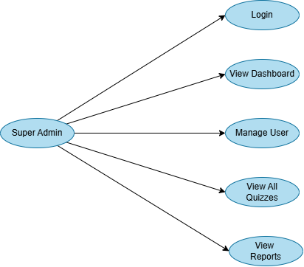

- Quiz Master
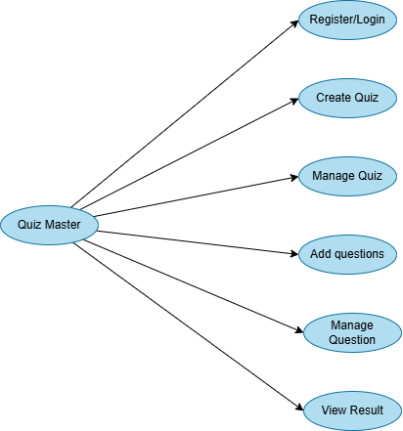
- Participant
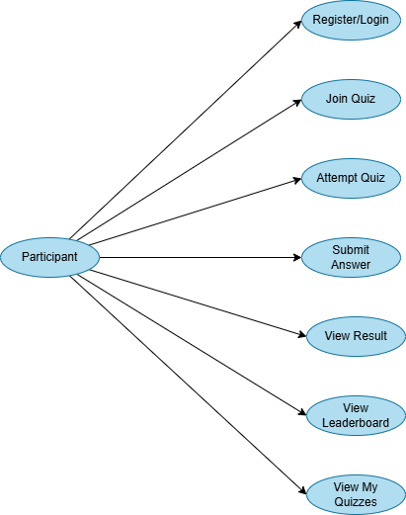

Design

5.1 Use Case Scenarios
Use Case Scenarios to describe the step-by-step interactions between users and the system for performing specific tasks. These scenarios help in understanding how the application behaves in real situations.

1. Scenario: User Registration
- The user opens the registration page
- Enters required details such as name, email, password, and role
- The system validates the input
- If valid, the user account is created
- The user is registered successfully

2. Scenario: User Login
- The user opens the login page
- Enters email and password
- The system validates credentials
- If valid, access is granted
- The user is redirected to the role-specific dashboard

3. Scenario: Create Quiz
- Quiz Master logs into the system
- Opens the Create Quiz page
- Enters quiz details
- Saves the quiz
- The system stores quiz data in the database

4. Scenario: Add Questions
- Quiz Master selects a quiz
- Opens the Add Question page
- Enters question text, options, correct answer, and marks
- Saves the question
- The system links the question to the selected quiz

5. Scenario: Join Quiz
- Participant logs into the system
- Enters the quiz code
- The system verifies the quiz and participant eligibility
- If valid, the participant is allowed to join the quiz

6. Scenario: Attempt Quiz
- Participant starts the quiz
- Questions are displayed one by one
- Participant selects or enters answers
- Each answer is submitted and stored in the Submission entity

7. Scenario: Result Generation
- After quiz completion, the system evaluates all submissions
- Calculates score and performance
- Stores the result in the Result entity
- Displays result to the participant

8. Scenario: View Leaderboard
- Participant opens the leaderboard
- The system retrieves ranked performance data
- Leaderboard is displayed based on score and submission records

5.2 Diagrams
Diagrams are used to visually represent the structure and flow of the Quiz System. They help in understanding the behavior of the system, data movement, and entity relationships in a simplified and structured form.

5.2.1 DFD

Level 0 DFD
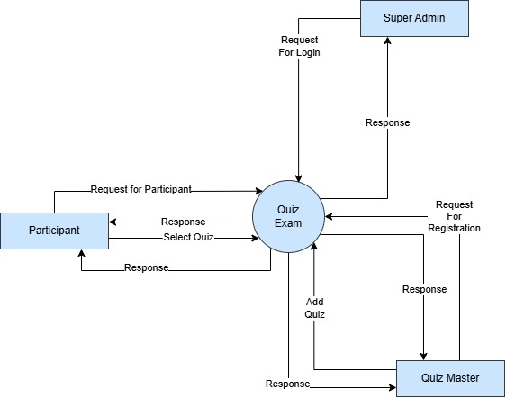

Level 1 DFD
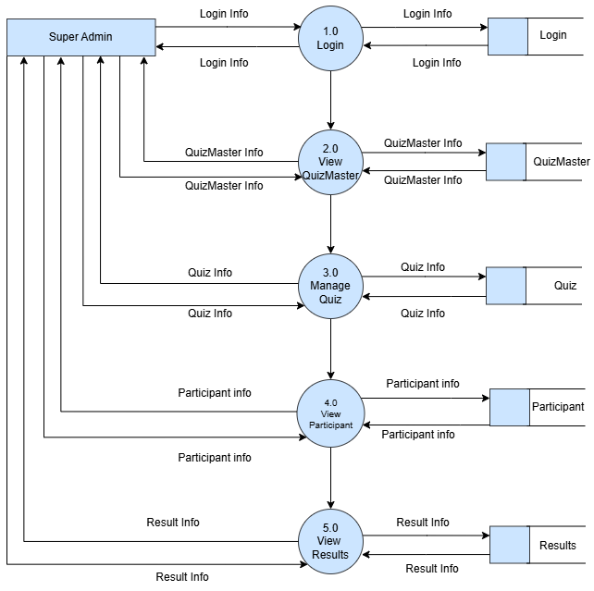
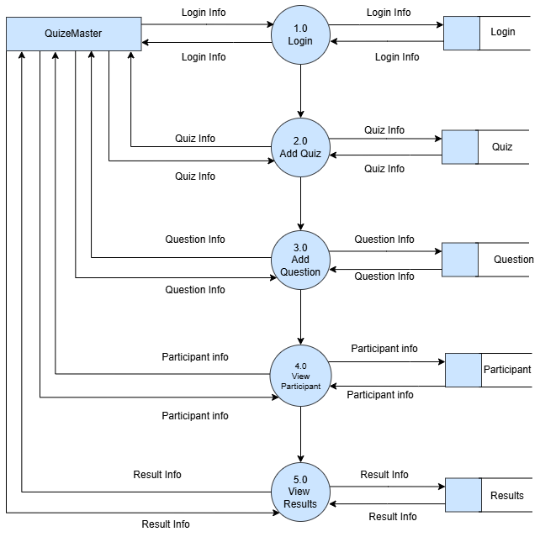
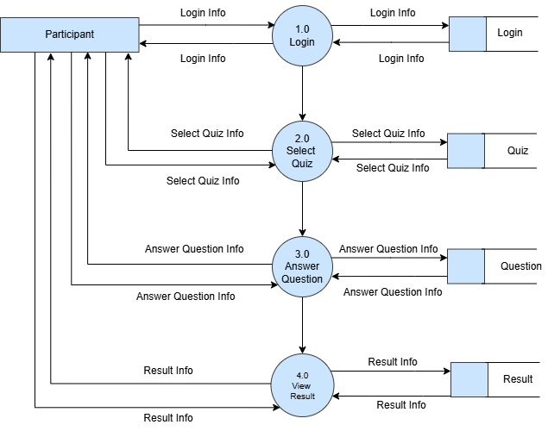

5.2.2 Entity Relationship Diagram
The Entity Relationship Diagram (ER Diagram) defines the database structure of the Quiz System. It represents the entities, their attributes, and their relationships.
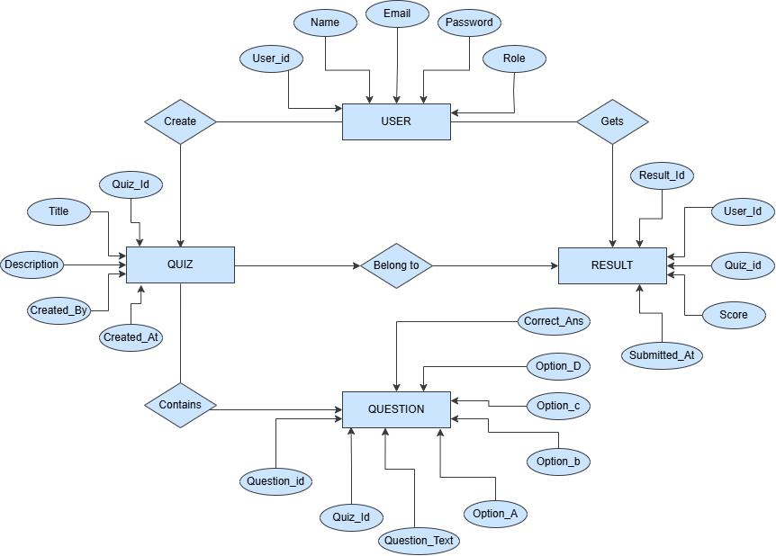

5.3 Data Dictionary
The Data Dictionary defines the data elements used in the Quiz System. It describes each table/collection, the fields it contains, the data type, and its purpose.

1. User Table
Field | Type | Description
User_ID | String | Unique ID
Name | String | User name
Email | String | Email
Password | String | Encrypted password
Role | String | User role

2. Quiz Table
Field | Type | Description
Quiz_ID | String | Unique ID
Title | String | Quiz title
Description | String | Description
Created_By | String | User reference
Created_At | Date | Created time

3. Question Table
Field | Type | Description
Question_ID | String | Unique ID
Quiz_ID | String | Quiz reference
Question_Text | String | Question
Option_A–D | String | Options
Correct_Answer | String | Correct option

4. Submission Table
Field | Type | Description
Submission_ID | String | Unique ID
Quiz_ID | String | Quiz reference
Question_ID | String | Question reference
Participant_ID | String | User reference
Selected_Answer | String | User answer
Is_Correct | Boolean | Correct or not
Marks_Awarded | Number | Marks
Submitted_At | Date | Time

5. Result Table
Field | Type | Description
Result_ID | String | Unique ID
User_ID | String | User reference
Quiz_ID | String | Quiz reference
Score | Number | Total score
Submitted_At | Date | Time

Implementation

6.1 Form & Report Layouts
Form layouts are designed to provide a clean, user-friendly, and consistent interface for user input across the system. Each form follows a structured layout with proper validation and feedback mechanisms.
- Landing Page
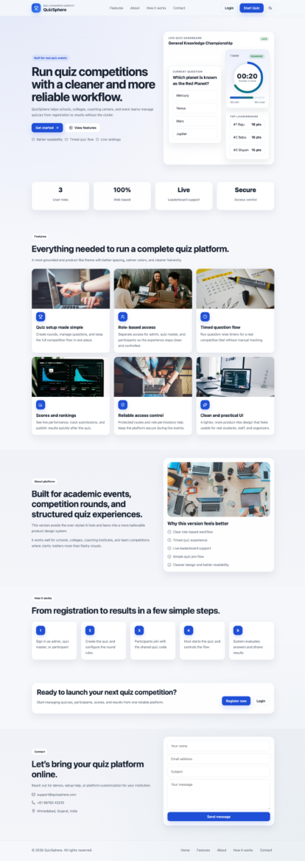


- Login Page
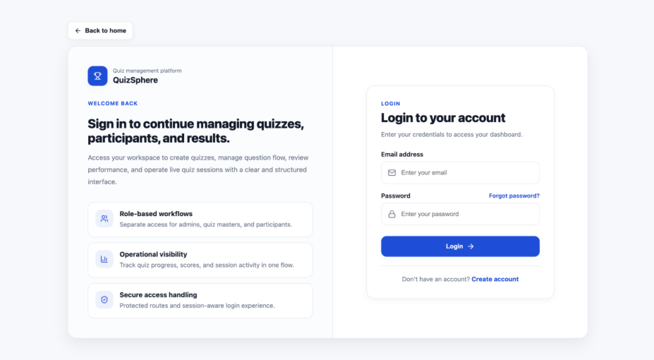
- Register Page
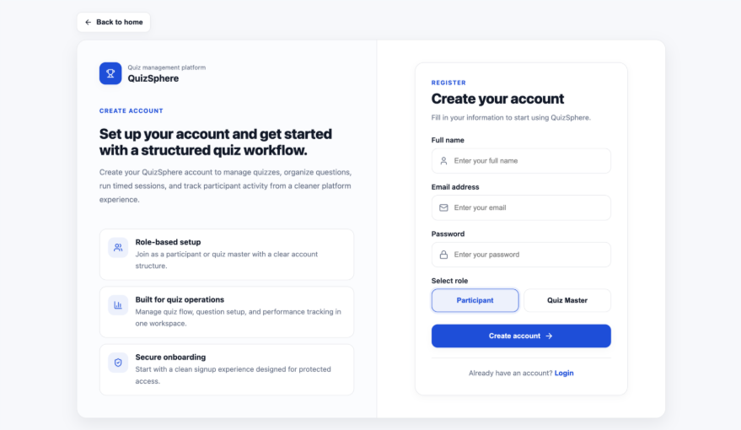

- Recover Page
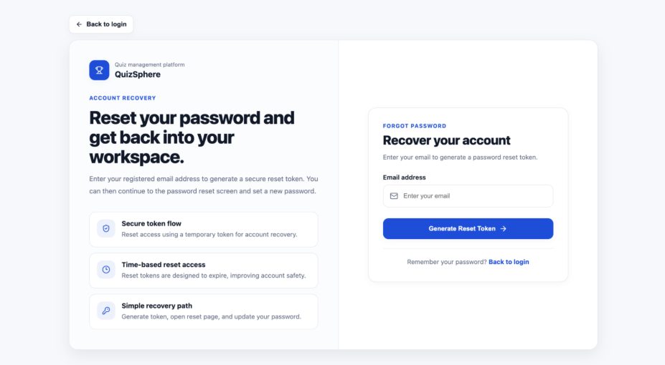
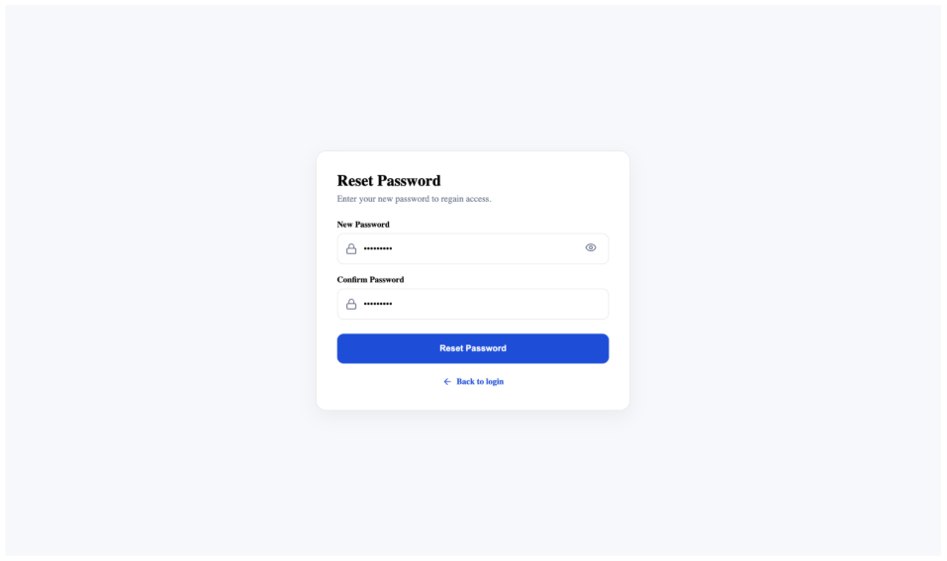

- Super Admin Dashboard
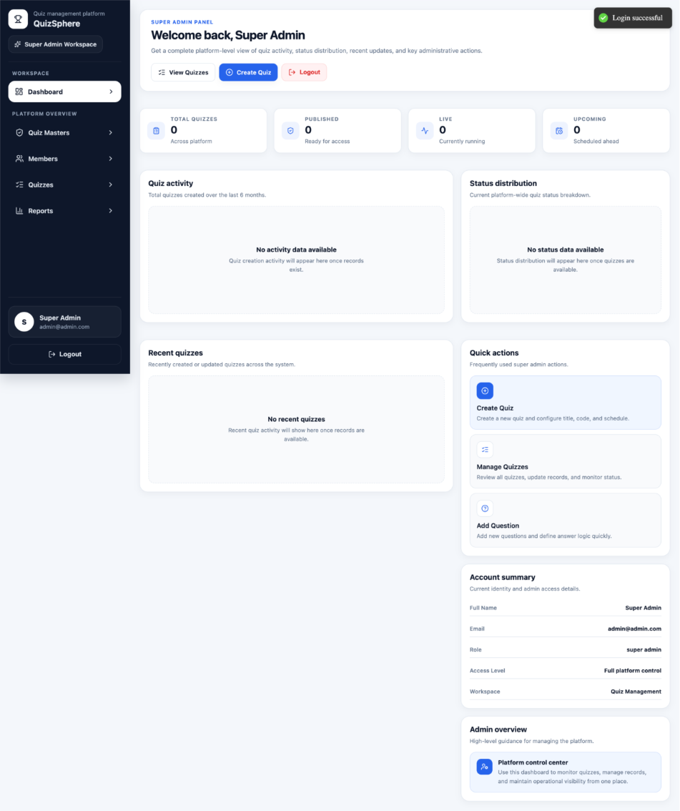

- Quiz Master List
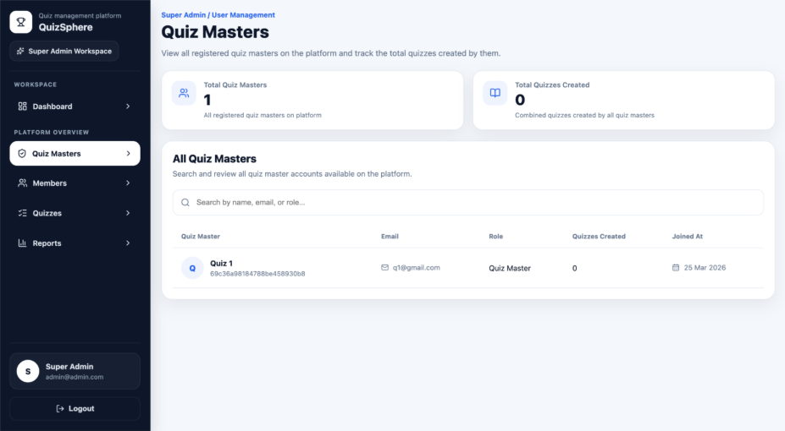
- Member List
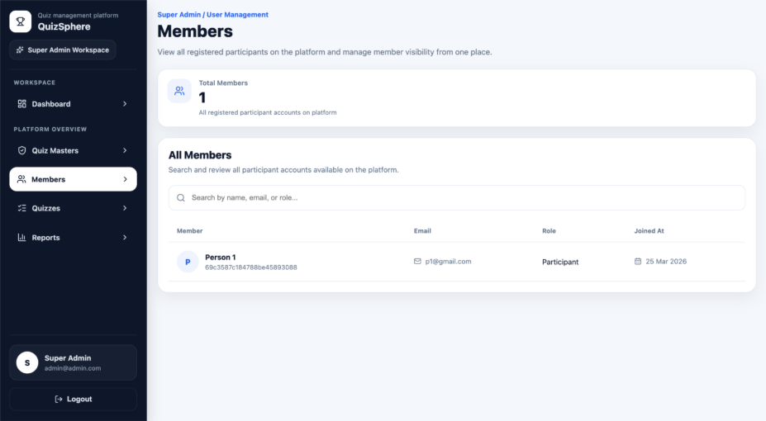

- All Quiz List
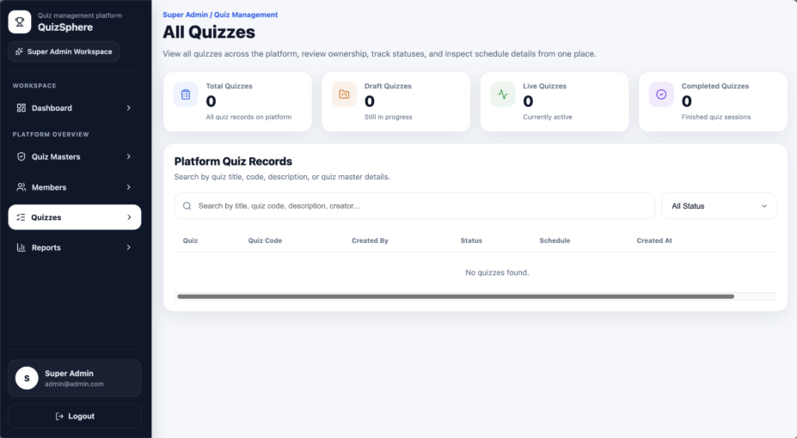
- Reports List
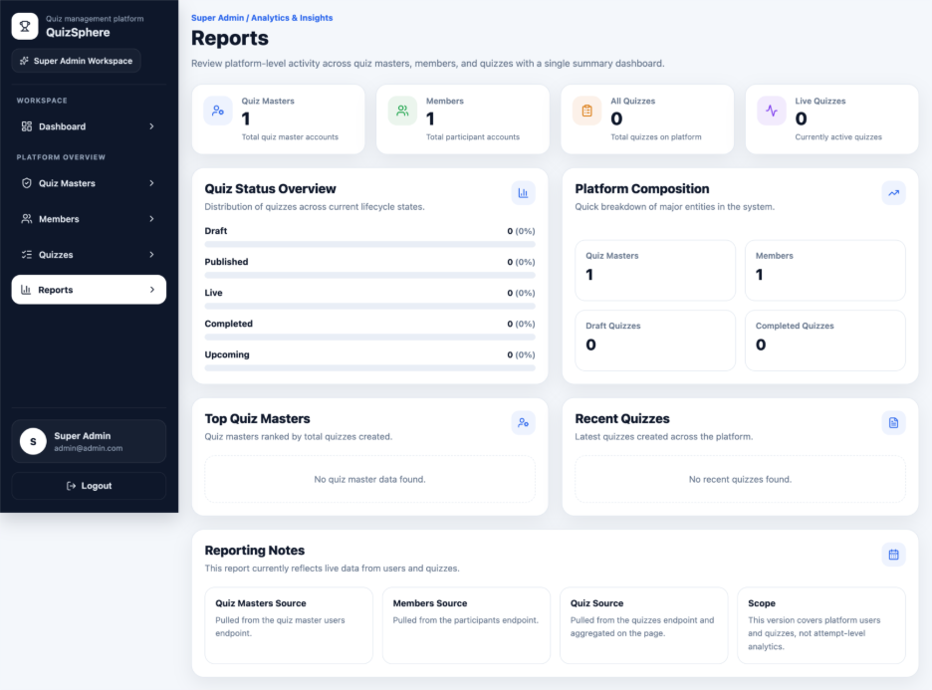
- Quiz Master Dashboard
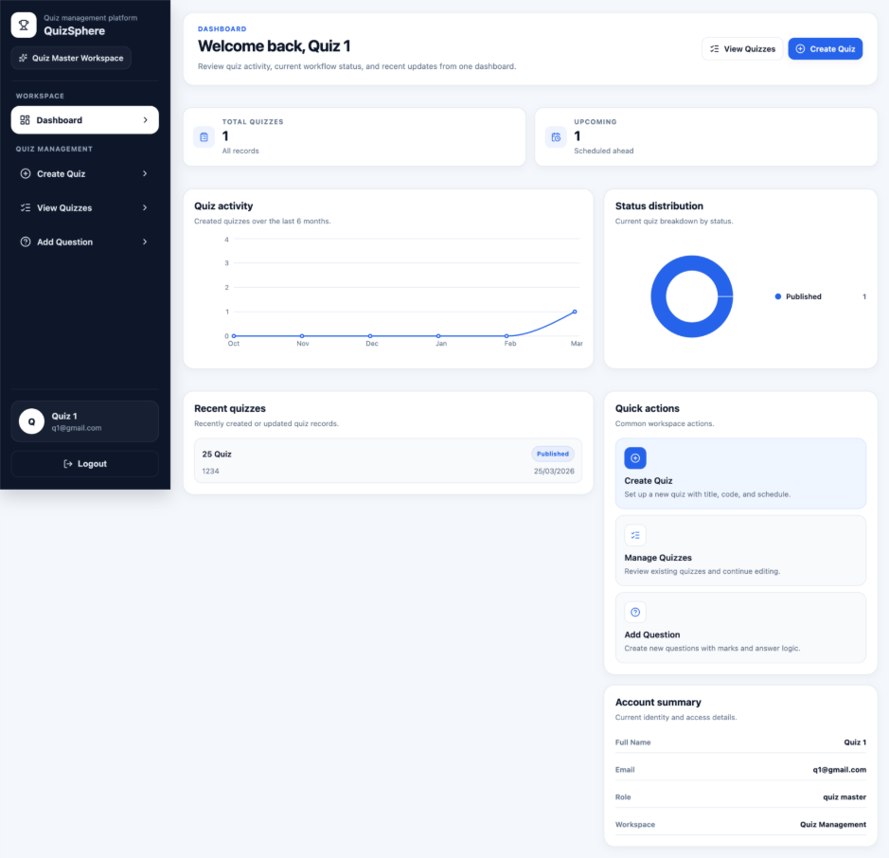

- Create Quiz
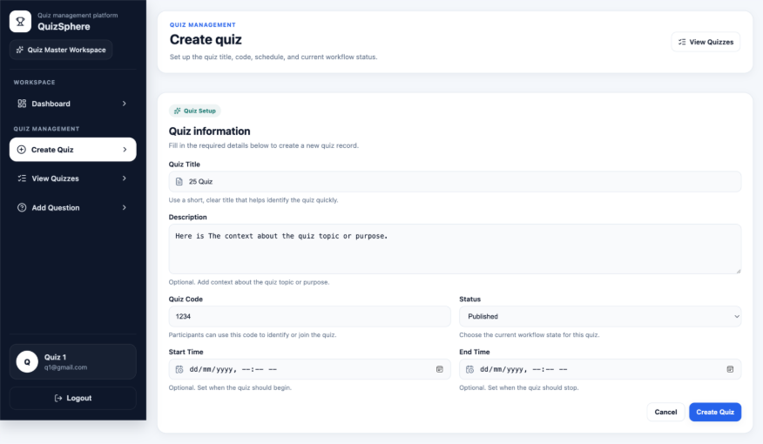
- All Quiz List
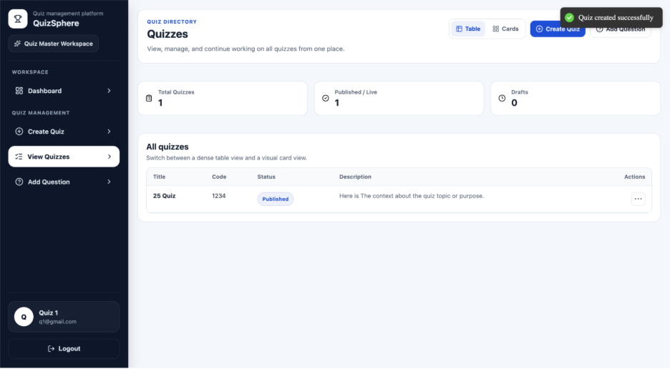

- Add New Question in Quiz
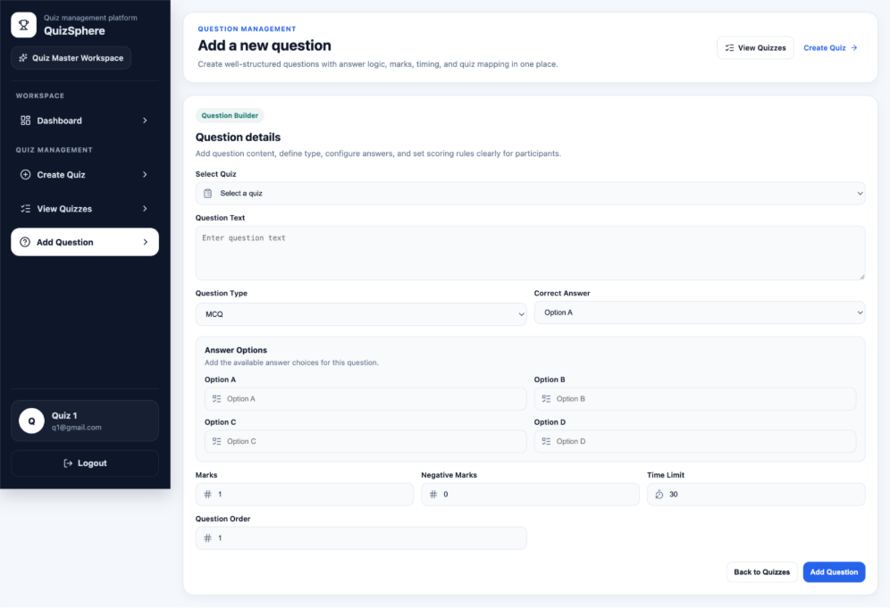
- Participant Dashboard
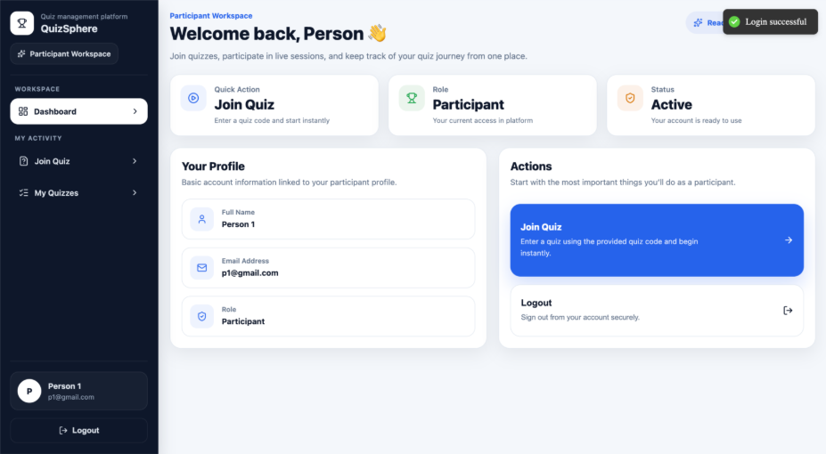
- Join Quiz
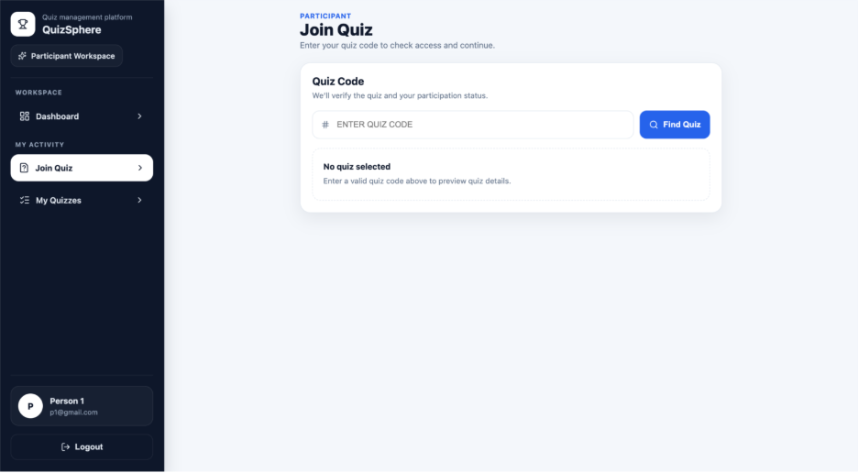
- Code Base Entry
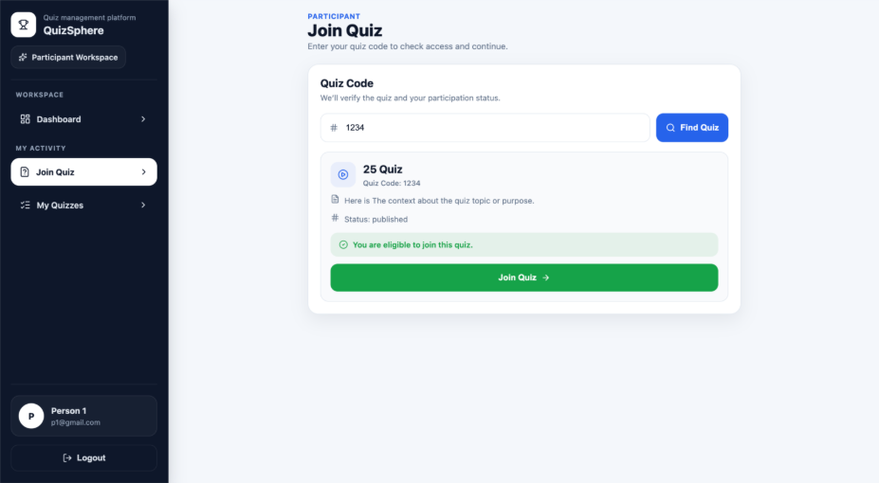

- In Quiz
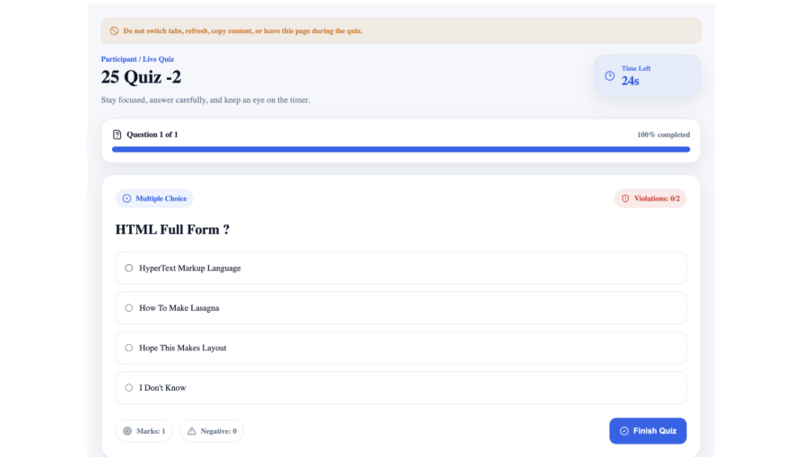
- Participant Can Copy, Screenshot, Change Tab
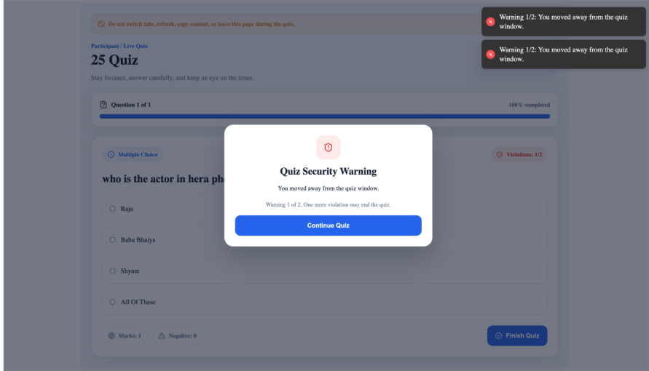

- Quiz Ended
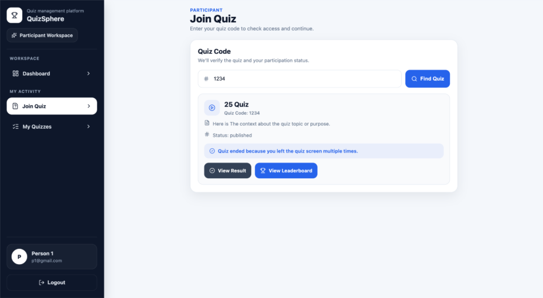
- Quiz Result
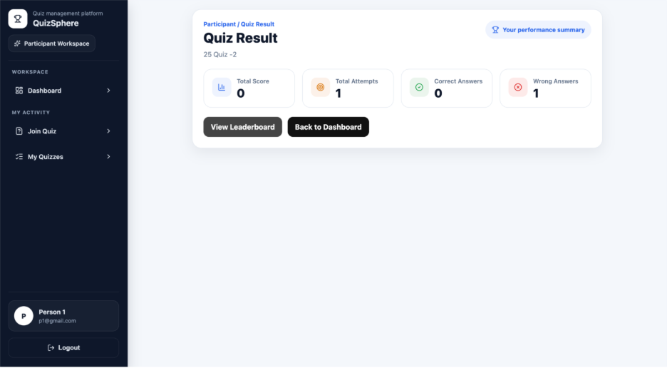

- All Attended Quiz List
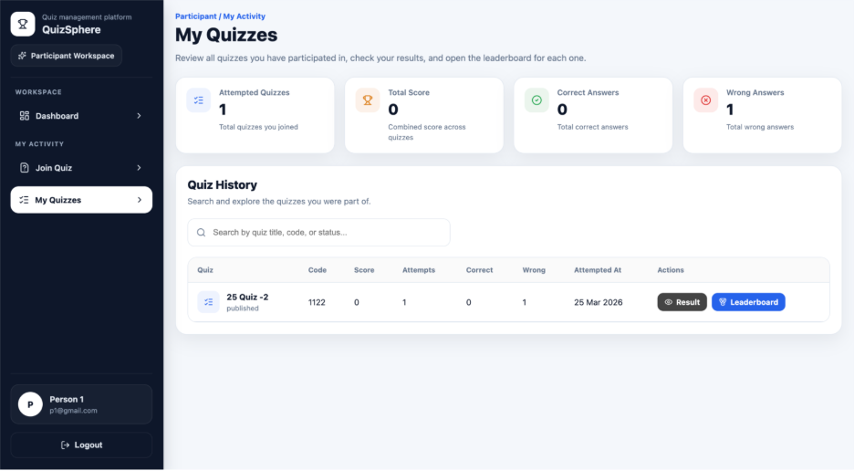
- Leaderboard List
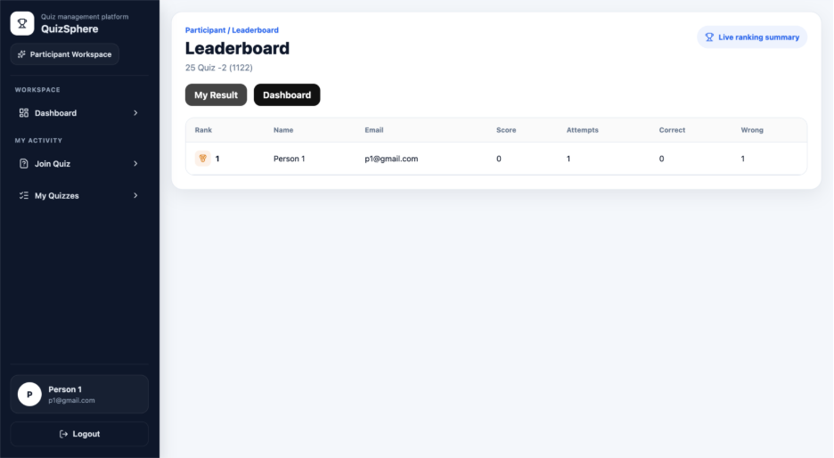

6.3 Coding Convention
Coding conventions are followed to ensure that the codebase remains clean, readable, and maintainable.

1. Naming Conventions
- Variables and functions: camelCase
- Components: PascalCase
- Files: meaningful and descriptive names

2. Code Structure
- Separation of frontend and backend
- Modular folder structure:
  - components
  - pages
  - routes
  - controllers
  - models

3. API Structure
- RESTful API design
- Proper HTTP methods:
  - GET (fetch data)
  - POST (create data)
  - PUT/PATCH (update data)
  - DELETE (remove data)

4. Error Handling
- Proper try-catch blocks
- Meaningful error messages
- Consistent API responses

5. Security Practices
- Password hashing using Bcrypt
- Token-based authentication using JWT
- Protected routes and middleware

6. Code Quality
- Reusable components in frontend
- Clean and readable logic
- Avoid unnecessary duplication
- Proper commenting where needed

Testing

7.1 Test Strategy
The testing strategy for the Quiz System is designed to validate functionality, usability, security, and overall system reliability. It includes systematic testing of both frontend and backend components.

1. Objective of Testing
The main objectives of testing are:
- To verify that all modules function correctly
- To ensure that user inputs are validated properly
- To confirm accurate answer evaluation and score calculation
- To check role-based access restrictions
- To ensure secure authentication and protected routing
- To identify and fix bugs before deployment

2. Types of Testing Performed

a) Unit Testing
Unit testing is performed on individual components and functions to verify that each unit works as expected.
Examples:
- Input validation in forms
- Password matching in reset password flow
- Score calculation logic
- Authentication checks

b) Integration Testing
Integration testing ensures that different modules work together correctly.
Examples:
- Frontend form submission with backend API
- Quiz creation and question linking
- Submission storage and result generation
- Leaderboard generation using submission data

c) System Testing
System testing validates the complete application as a whole.
Examples:
- User login and dashboard redirection
- Quiz creation to result display
- Participant flow from joining quiz to viewing leaderboard
- Super Admin access to reports and user data

d) Validation Testing
Validation testing checks whether the system satisfies user requirements and performs according to expected behavior.
Examples:
- Required field validation
- Preventing duplicate quiz attempts
- Restricting unauthorized access
- Ensuring quiz participation rules are enforced

e) Usability Testing
Usability testing ensures that the system is easy to use and provides a clear user experience.
Examples:
- Easy navigation between pages
- Proper alignment of forms and buttons
- Clear labels, messages, and notifications
- Responsive UI behavior

3. Test Environment
The testing of the Quiz System is conducted in the following environment:
- Operating System: Windows / macOS
- Frontend: React.js
- Backend: Node.js and Express.js
- Database: MongoDB
- Browser: Google Chrome / Microsoft Edge
- API Testing Tool: Postman

4. Testing Approach
The testing process follows a step-by-step approach:
- Test individual modules independently
- Integrate modules and test data flow
- Validate complete role-based user journeys
- Fix identified bugs
- Re-test the system to ensure stability

7.2 Test Cases
The following test cases were designed and executed to verify the functionality of the Quiz System.

Test Case 1: User Registration
Test Case ID | TC_01
Test Scenario | Register a new user
Input | Valid name, email, password, role
Expected Result | User account should be created successfully
Actual Result | Account created successfully
Status | Pass

Test Case 2: Duplicate User Registration
Test Case ID | TC_02
Test Scenario | Register with an existing email
Input | Existing email address
Expected Result | System should display “User already exists” message
Actual Result | Proper error message displayed
Status | Pass

Test Case 3: User Login with Valid Credentials
Test Case ID | TC_03
Test Scenario | Login with correct email and password
Input | Registered email and correct password
Expected Result | User should log in successfully and be redirected to dashboard
Actual Result | Login successful and redirected correctly
Status | Pass

Test Case 4: User Login with Invalid Credentials
Test Case ID | TC_04
Test Scenario | Login with incorrect password
Input | Registered email and wrong password
Expected Result | System should show invalid credentials message
Actual Result | Error message displayed
Status | Pass

Test Case 5: Forgot Password
Test Case ID | TC_05
Test Scenario | Request password reset
Input | Registered email
Expected Result | Reset token should be generated successfully
Actual Result | Reset token generated
Status | Pass

Test Case 6: Reset Password
Test Case ID | TC_06
Test Scenario | Reset password with valid token
Input | Valid reset token and new password
Expected Result | Password should be updated successfully
Actual Result | Password reset successful
Status | Pass

Test Case 7: Create Quiz
Test Case ID | TC_07
Test Scenario | Create a new quiz
Input | Valid quiz title and description
Expected Result | Quiz should be created and stored
Actual Result | Quiz created successfully
Status | Pass

Test Case 8: Add Question
Test Case ID | TC_08
Test Scenario | Add question to quiz
Input | Question text, options, correct answer, marks
Expected Result | Question should be added successfully
Actual Result | Question added successfully
Status | Pass

Test Case 9: Join Quiz with Valid Code
Test Case ID | TC_09
Test Scenario | Participant joins quiz using valid code
Input | Valid quiz code
Expected Result | Quiz details should be displayed and participant should be allowed to continue
Actual Result | Quiz displayed successfully
Status | Pass

Test Case 10: Join Quiz with Invalid Code
Test Case ID | TC_10
Test Scenario | Participant enters invalid quiz code
Input | Invalid quiz code
Expected Result | System should show quiz not found message
Actual Result | Proper error displayed
Status | Pass

Test Case 11: Prevent Duplicate Quiz Attempt
Test Case ID | TC_11
Test Scenario | Participant tries to rejoin already attempted quiz
Input | Quiz code of already attempted quiz
Expected Result | System should block rejoin and show result/leaderboard options
Actual Result | Rejoin blocked successfully
Status | Pass

Test Case 12: Submit Quiz Answers
Test Case ID | TC_12
Test Scenario | Submit answers during quiz attempt
Input | Selected answers for questions
Expected Result | Submissions should be stored and evaluated
Actual Result | Answers submitted successfully
Status | Pass

Test Case 13: Result Generation
Test Case ID | TC_13
Test Scenario | Generate result after quiz completion
Input | Completed quiz submissions
Expected Result | Result should display score, correct answers, and wrong answers
Actual Result | Result generated successfully
Status | Pass

Test Case 14: Leaderboard Display
Test Case ID | TC_14
Test Scenario | View leaderboard for quiz
Input | Completed quiz data
Expected Result | Ranked participant list should be displayed
Actual Result | Leaderboard displayed successfully
Status | Pass

Test Case 15: Role-Based Access Control
Test Case ID | TC_15
Test Scenario | Access restricted page with unauthorized role
Input | User with invalid role access
Expected Result | Access should be denied or redirected
Actual Result | Unauthorized access blocked
Status | Pass

Test Case 16: Quiz Security Violation Handling
Test Case ID | TC_16
Test Scenario | Participant violates quiz rules (tab switch / leave page) repeatedly
Input | Multiple security violations during quiz
Expected Result | System should end quiz and prevent rejoin
Actual Result | Quiz terminated successfully
Status | Pass

Future Enhancement

1. Real-Time Quiz System
- Enable live quiz sessions with real-time synchronization
- Allow multiple participants to compete simultaneously

2. Advanced Analytics Dashboard
- Provide detailed insights such as:
  - User performance trends
  - Quiz difficulty analysis
  - Engagement metrics

3. AI-Based Question Generation
- Automatically generate questions using AI
- Suggest difficulty levels and question types

4. Timer-Based Quiz Control
- Add time limits for quizzes and individual questions
- Auto-submit quiz after time expires

5. Mobile Application
- Develop native mobile apps (Android / iOS)
- Improve accessibility and user engagement

6. Email & Notification System
- Send notifications for:
  - Quiz invitations
  - Result announcements
  - Password reset links

7. Multi-Language Support
- Allow users to access the system in different languages
- Improve usability for a wider audience

8. Enhanced Security Features
- Add proctoring features (camera monitoring, tab tracking)
- Prevent cheating and unauthorized access

Bibliography

Web Technologies & Documentation
- React.js Official Documentation – https://react.dev
- Node.js Official Documentation – https://nodejs.org
- Express.js Documentation – https://expressjs.com
- MongoDB Documentation – https://www.mongodb.com/docs

Libraries & Tools
- Axios Documentation – https://axios-http.com
- JSON Web Token (JWT) – https://jwt.io
- Bcrypt.js – https://www.npmjs.com/package/bcryptjs
- React Router – https://reactrouter.com

Development Tools
- Visual Studio Code
- Postman API Testing Tool

Online References
- Stack Overflow – https://stackoverflow.com
- GitHub Repositories for reference and learning

